 Calculating Family

Expenses using Service Now

Project overview

The Family Expenses Management Project is designed to help users track and manage both high-level and daily financial activities within a household. The project involved:

- Creating custom tables (Family Expenses and Daily Expenses) to store structured expense data.

- Implementing auto-numbering for unique record identification.

- Designing form layouts for better user experience.

- Establishing one-to-many relationships between the two tables.

- Adding related lists for seamless navigation and visibility.

- Developing business rules to automate calculations and validations.

Overall, this project showcases the flexibility of ServiceNow in building applications beyond IT service management, applying its low-code capabilities to solve everyday challenges like financial tracking and household budgeting

Setting up ServiceNow Instance
- Sign up for a developer account on the ServiceNow Developer site “https://developer.servicenow.com”.

- Click on "Request Instance" to create a new ServiceNow instance.

- Navigate to System Applications → Studio to create and manage the custom application.

- Create a new application named Family Expenses Management.

- Now you will navigate to the ServiceNow.

Creation of Update Set
- Go to System Update Sets → Local Update Sets.

- Click New, provide a name (e.g., Family Expenses Update), and make it the current update set.
- All changes will be captured here for portability.

- Then click on Submit and Make current.

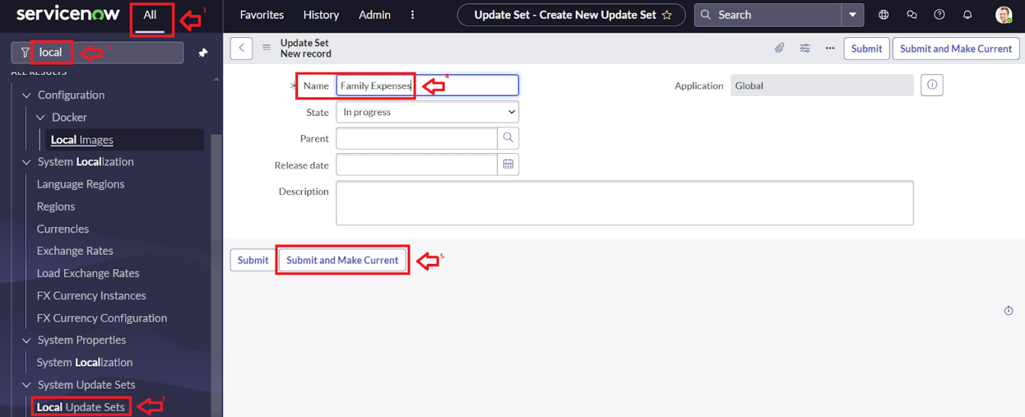

Creation of Table

Creation of Family Expenses Table
- Navigate to System Definition → Tables.

- Click New and create a table called Family Expenses (u_family_expenses).
- Go to the Header and right click there>> click on Save.

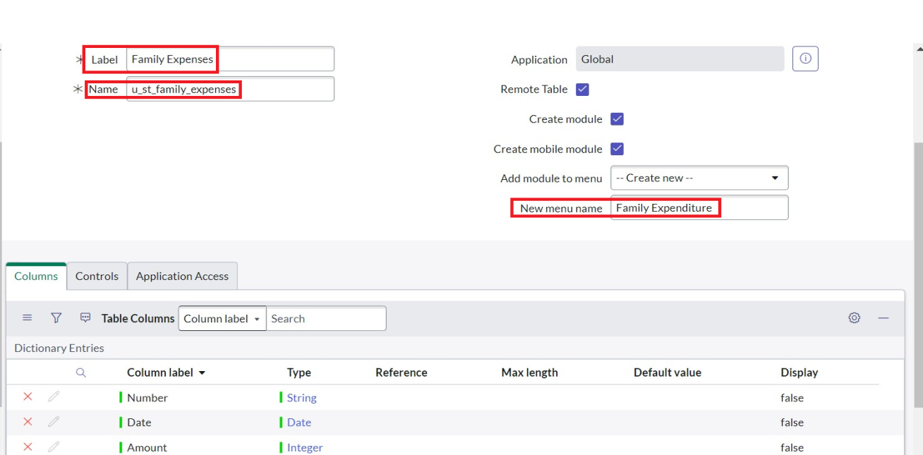

Creation of Columns(Fields)

Insert a new row in Fields

- Give the details as:

- Number (Auto-number, unique identifier)
- Expense Details (String)
- Total Amount (Currency/Integer)
- Date of Expense (Date/Time)
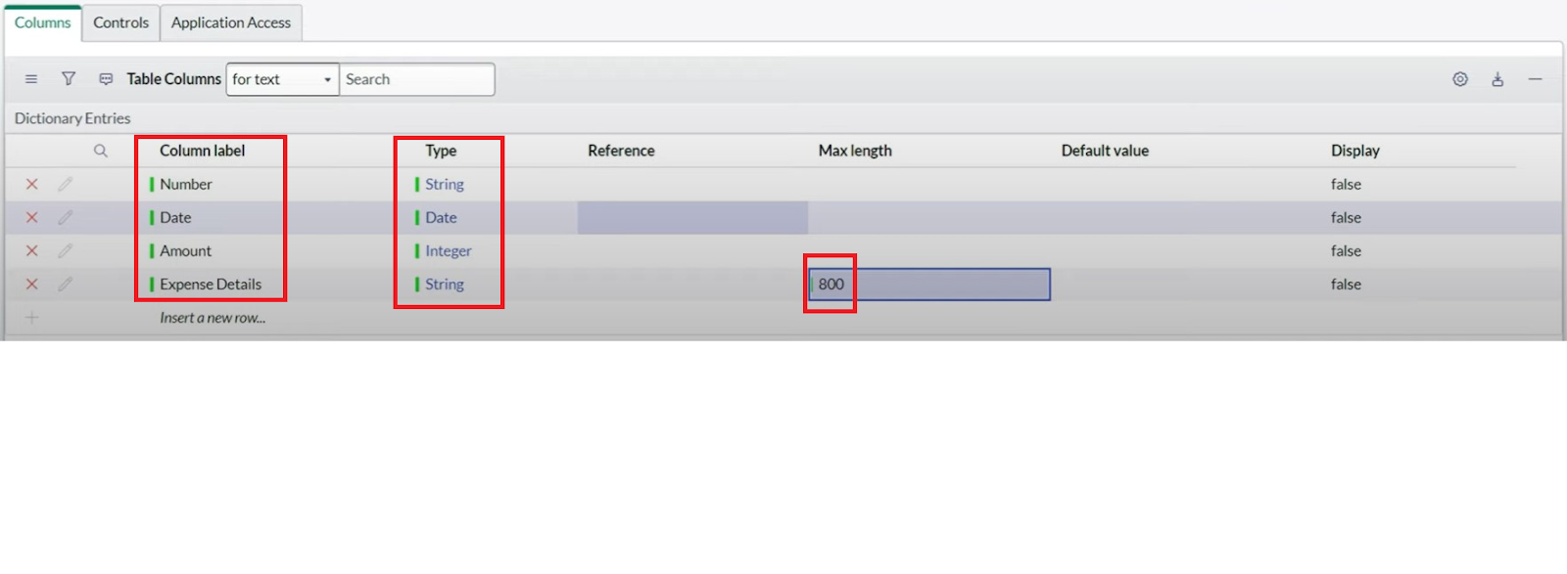

Making Number Field an Auto-Number

- Advanced view

- In Default Value:

- Use dynamic default : check the box
- Dynamic default value : Get Next Padded Number

- Navigate to Number Maintenance

- Enter the below Details:
Table : Family Expenses
Prefix : MFE
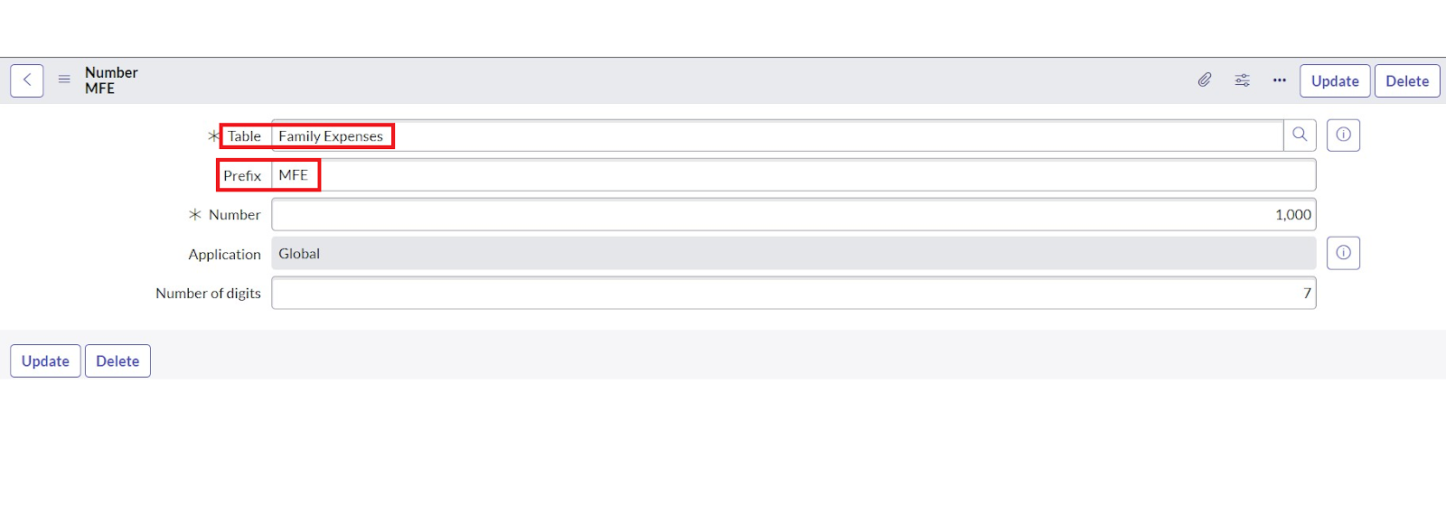

Configure the Form

- Open the form Desgin layout for Family Expenses.

- Customize or Drag Drop the form as per your requirement.

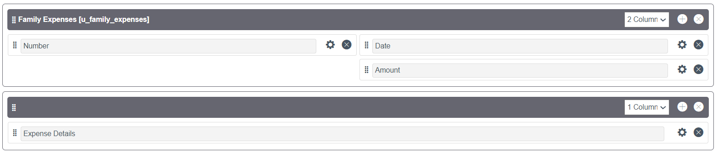

- Arrange fields logically(Number (Auto-number, unique identifier),Expense Details (String),Total Amount (Currency/Integer),Date of Expense (Date/Time)

- Make Number Read-Only Field by clicking on the gear icon and checking Read-Only

- Make Date, Amount Mandatory Field by clicking on the gear icon and checking Mandatory

Creation of Table(Daily Expenses)

Creation of Daily Expenses Table
- Navigate again to System Definition → Tables.
- Create another table called Daily Expenses (u_daily_expenses).
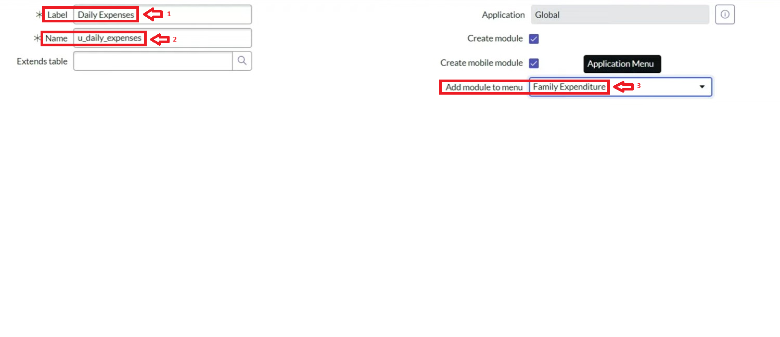

Creation of Columns(Fields)

Insert a new row in Fields
- Give the details as:
- Number (Auto-number, unique identifier)
- Expense Details (String)
- Total Amount (Currency/Integer)
- Comments(String)
- Family Member Name(References)

Making Number Field an Auto-Number

- Advanced view

- In Default Value:
  - Use dynamic default : check the box
  - Dynamic default value : Get Next Padded Number

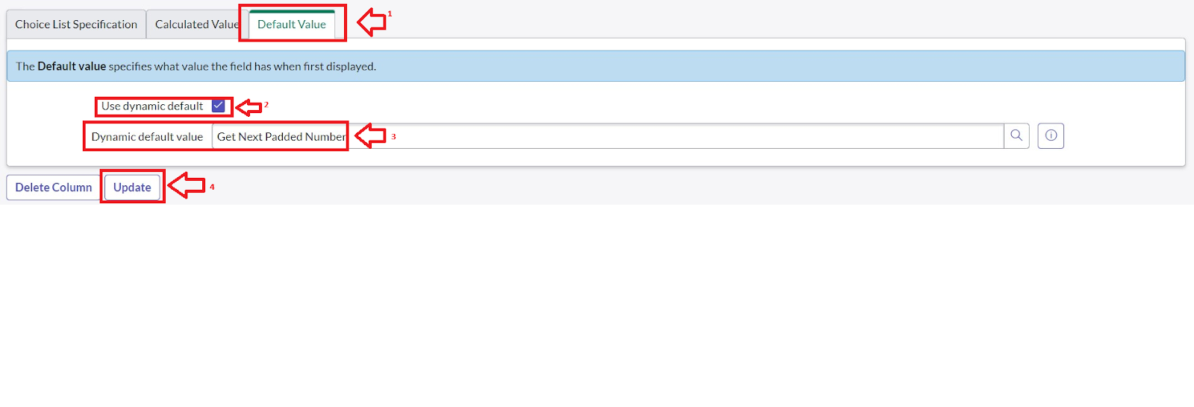

- Navigate to Number Maintenance

- Enter the below Details:
Table : Family Expenses
Prefix : MFE

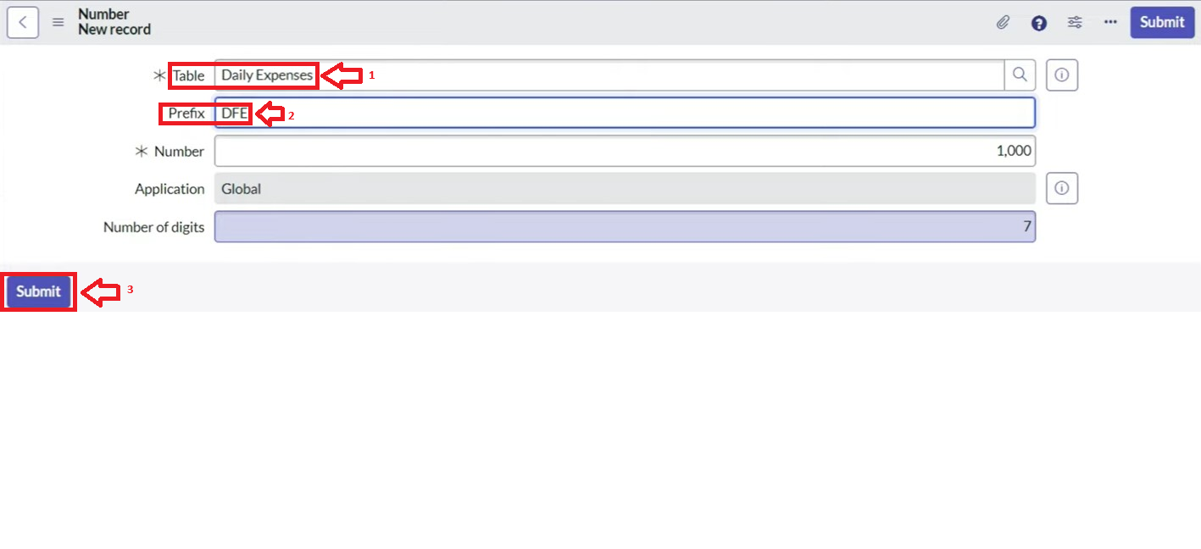

Configure the Form

- Open the form Desgin layout for Daily Expenses.

- Customize or Drag Drop the form as per your requirement.

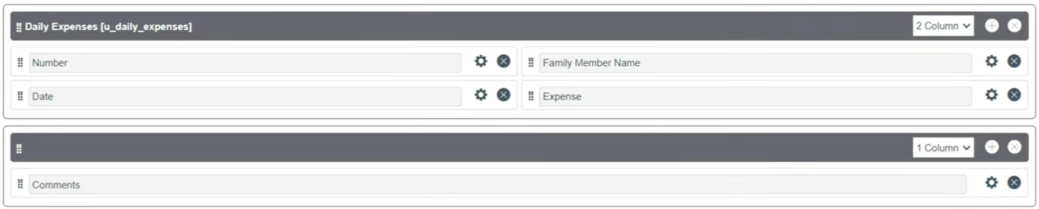

- Arrange fields logically(Number (Auto-number, unique identifier),Total Amount (Currency/Integer),Date of Expense (Date/Time), Comments(String),Family Member Name(References))

- Make Number Read-Only Field by clicking on the gear icon and checking Read-Only

- Make Date, Family Member Name Mandatory Field by clicking on the gear icon and checking Mandatory

Creation of Relationship

Creation of Relationship between Family Expenses and Daily Expenses tables

Establish a one-to-many relationship:

One Family Expense record → Many Daily Expenses

Use a Reference field (Family Expense Reference) in Daily Expenses pointing to Family Expenses table.

Configuring Related List on Family Expenses

- Go to Form Layout of Family Expenses.

- Add Daily Expenses as a related list.
- Now, users can view all related daily expenses directly under each family expense record.
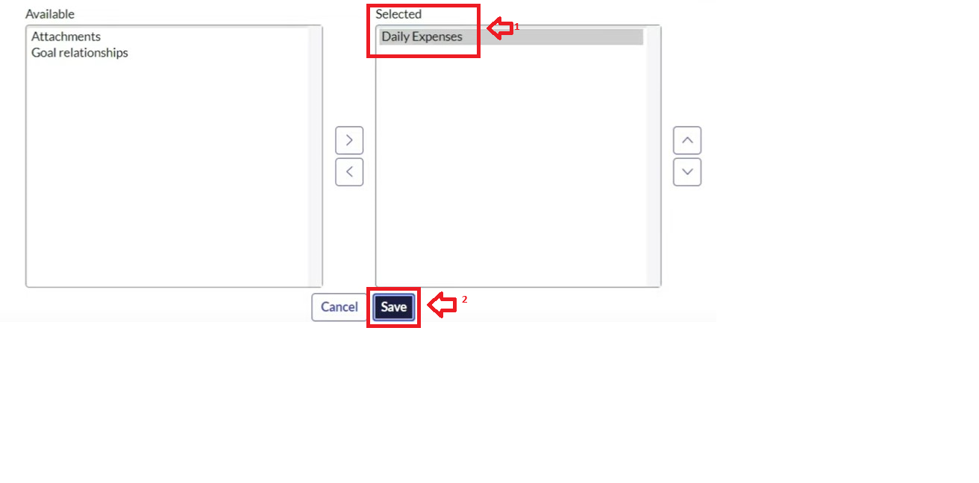

Creation of Business Rules

Navigate to System Definition → Business Rules.
- Enter the Details:
Name : Family Expenses BR
Table : Select Daily Expenses
Check Advanced

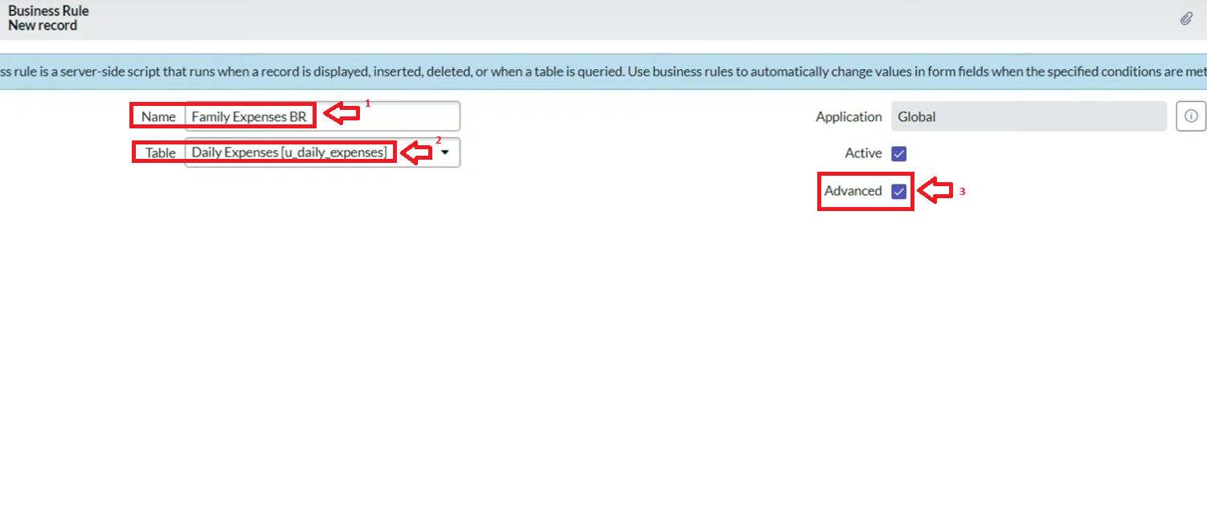

- In when to run Check Insert and Update

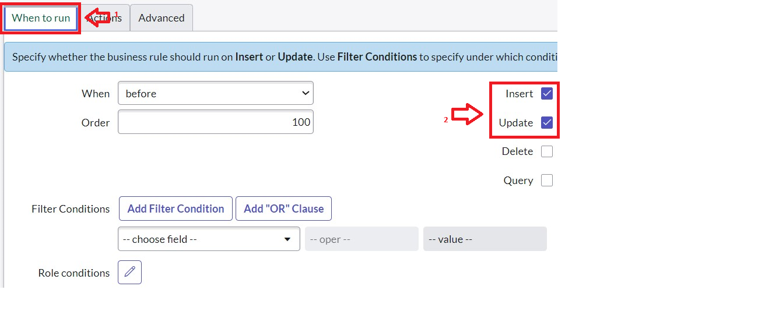

- In Advance(we write the code): Write the below code >>

(function executeRule(current, previous /*null when async*/) {

var FamilyExpenses = new GlideRecord('u_family_expenses');

FamilyExpenses.addQuery('u_date',current.u_date);
FamilyExpenses.query();
if(FamilyExpenses.next())
{
FamilyExpenses.u_amount += current.u_expense;

FamilyExpenses.u_expense_details += ">"+current.u_comments+":"+"Rs."+current.u_expense+"/-";
FamilyExpenses.update();
}
else
{
var NewFamilyExpenses = new GlideRecord('u_family_expenses');
NewFamilyExpenses.u_date = current.u_date;
NewFamilyExpenses.u_amount = current.u_expense;
NewFamilyExpenses.u_expense_details += ">"+current.u_comments+":"+"Rs."+current.u_expense+"/-";
NewFamilyExpenses.insert();
}

})(current, previous);

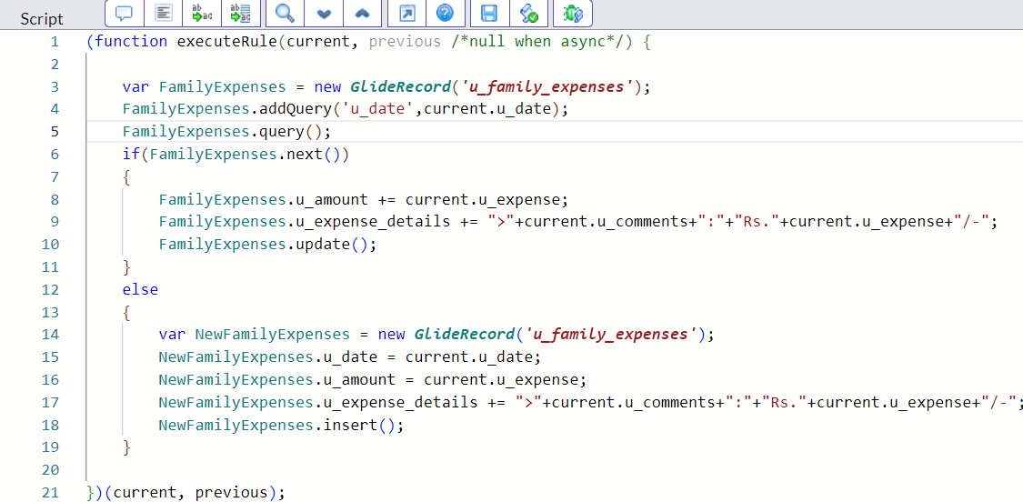

Configure the Relationship

Navigate to Relationships
- n that, open Daily Expenses Relationship.
- For Applies to table : Select Family Expenses.
- In Query with : write the below Query.

(function refineQuery(current, parent) {

// Add your code here, such as current.addQuery(field, value);
current.addQuery('u_date',parent.u_date);
current.query();
s
})(current, parent);

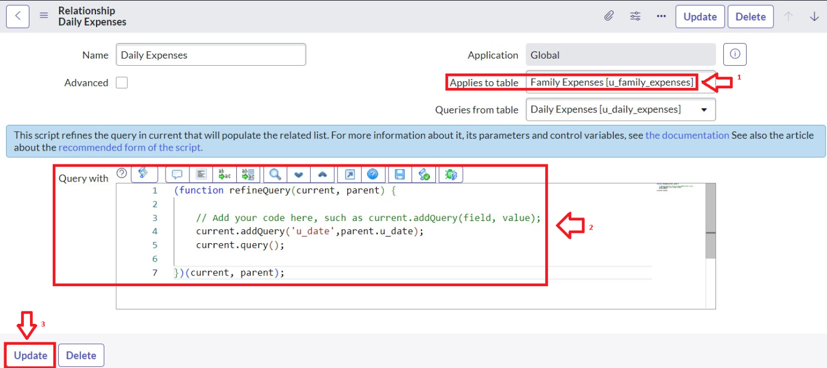

Conclusion

The Family Expenses Management application in ServiceNow provides a structured and automated way of tracking household spending. By leveraging custom tables, relationships, auto-numbering, and business rules, the application ensures both accuracy and efficiency. The Family Expenses table captures the high-level summary of expenses for each family member, while the Daily Expenses table records granular transaction-level details. The relationship between these tables provides visibility into how daily spending contributes to overall family expenses, while business rules automate calculations and validations to reduce manual work. This project demonstrates how ServiceNow’s extensibility can be applied beyond IT workflows into practical real-life scenarios, like managing household budgets, and can be further enhanced by adding reporting, dashboards, and notifications for deeper insights.

THANK YOU

TEAM
SASIKA R (LEADER)
SARANYA K
SESHALATHA P
SHARMILA M

